# Economic Inequality, Social Mobility, and Political Polarization in the U.S. (1924–2024)

## 1. Economic Inequality in the U.S. (1924–2024)

### 1.a Historical trend of U.S. income concentration:

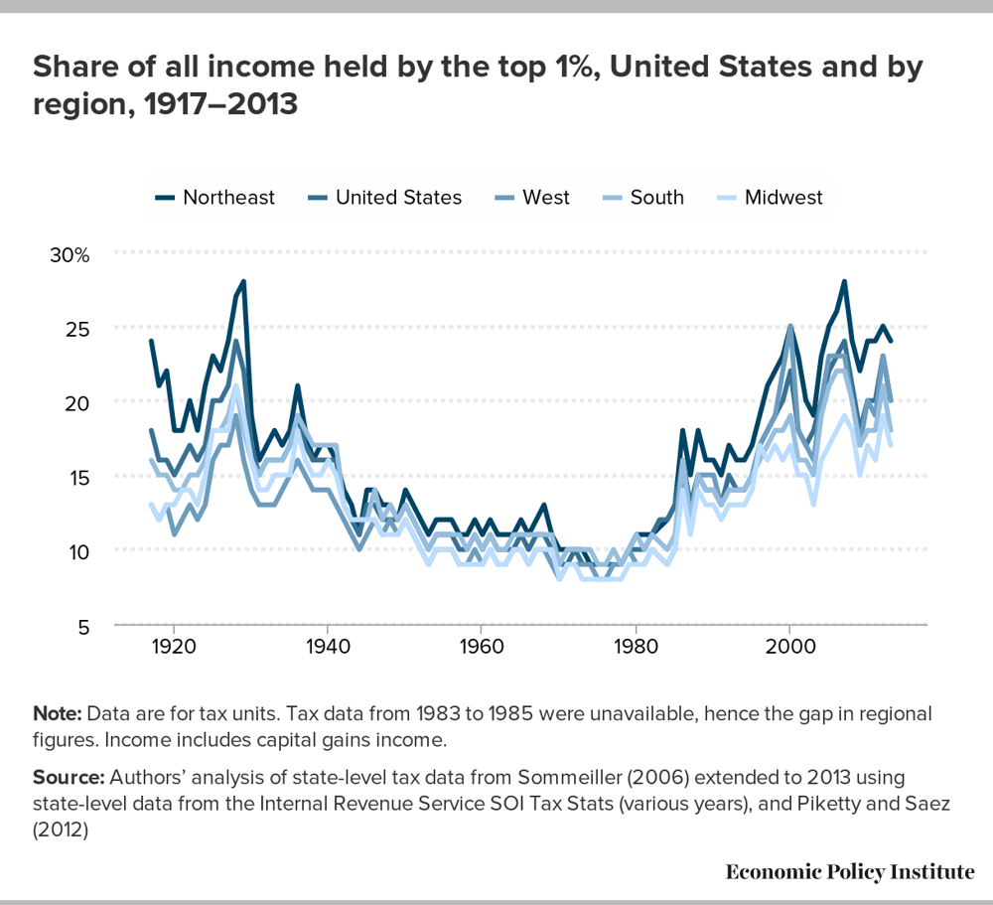The share of all income held by the top 1% followed a **U-shape** over the past century, peaking around the late 1920s, bottoming out mid-century, and rising sharply after 1980 ([This visualization shows you 35 years of US income inequality | World Economic Forum](https://www.weforum.org/stories/2016/11/this-visualization-shows-you-35-years-of-us-income-inequality/)) ([Why the Roaring Twenties Left Many Americans Poorer | HISTORY](https://www.history.com/news/roaring-twenties-labor-great-depression#:~:text=In%20fact%2C%20income%20inequality%20increased,for%20a%20family%20of%20five)) ([Political Polarization](https://legacy.voteview.com/political_polarization_2015.htm#:~:text=Polarization%20declined%20in%20both%20chambers,mark%20an%20acceleration%20of%20the)).

* **In 1928**, the top 1% of families received about **23.9% of all pre-tax income** ([Why the Roaring Twenties Left Many Americans Poorer | HISTORY](https://www.history.com/news/roaring-twenties-labor-great-depression#:~:text=In%20fact%2C%20income%20inequality%20increased,for%20a%20family%20of%20five)).
* Inequality then **fell dramatically** during the Great Depression and World War II – the top 1% income share dropped to around 8–10% by the 1950s. This era (1940s–1960s) saw the **lowest inequality** (household income Gini coefficients around **0.39** in 1968) ([How Has Income Inequality Changed over the Years?](https://www.stlouisfed.org/on-the-economy/2016/june/how-has-income-inequality-changed-years#:~:text=measured%20by%20the%20Gini%20coefficient,coefficient%20was%20flat%20or%20declining)). Since the late 1970s, however, inequality has **steadily climbed**.
* **By 2013** the income Gini reached **0.482**, the highest since the 1920s ([How Has Income Inequality Changed over the Years?](https://www.stlouisfed.org/on-the-economy/2016/june/how-has-income-inequality-changed-years#:~:text=measured%20by%20the%20Gini%20coefficient,coefficient%20was%20flat%20or%20declining)). The top 1% now capture roughly **20–22% of income** (comparable to Roaring ’20s levels) ([Why the Roaring Twenties Left Many Americans Poorer | HISTORY](https://www.history.com/news/roaring-twenties-labor-great-depression#:~:text=In%20fact%2C%20income%20inequality%20increased,for%20a%20family%20of%20five)) ([How Has Income Inequality Changed over the Years?](https://www.stlouisfed.org/on-the-economy/2016/june/how-has-income-inequality-changed-years#:~:text=measured%20by%20the%20Gini%20coefficient,coefficient%20was%20flat%20or%20declining)), while the **bottom 90%’s share** has correspondingly declined (from ~68% in 1979 to ~53% by 2014) ([This visualization shows you 35 years of US income inequality | World Economic Forum](https://www.weforum.org/stories/2016/11/this-visualization-shows-you-35-years-of-us-income-inequality/#:~:text=the%20visualization)) ([This visualization shows you 35 years of US income inequality | World Economic Forum](https://www.weforum.org/stories/2016/11/this-visualization-shows-you-35-years-of-us-income-inequality/#:~:text=____________________________________________)).

### 1.b Major contributors:

Major contributors to economic inequality: faster wage growth for top earners, shifts in tax policy, globalization, and technology changes favoring skilled labor.

#### 1.b.1 Wealth Distribution

Wealth inequality is even more skewed. Over 1924–2024 it also traces a U-shape. From the 1930s to the 1970s there was a *“democratization of wealth,”* but since then wealth concentration has surged ([Exploding wealth inequality in the United States - Equitable Growth](https://equitablegrowth.org/exploding-wealth-inequality-united-states/#:~:text=Wealth%20inequality%2C%20it%20turns%20out%2C,than%20%2420%20million%20in%202012)) ([Exploding wealth inequality in the United States - Equitable Growth](https://equitablegrowth.org/exploding-wealth-inequality-united-states/#:~:text=Figure%201%20shows%20that%20wealth,barons%20of%20the%20Gilded%20Age)). For example, the top *0.1%* of U.S. families held about **7%** of wealth in the late 1970s but about **22%** by 2012 – nearly as high as in the late 1920s ([Exploding wealth inequality in the United States - Equitable Growth](https://equitablegrowth.org/exploding-wealth-inequality-united-states/#:~:text=Wealth%20inequality%2C%20it%20turns%20out%2C,than%20%2420%20million%20in%202012)) ([Exploding wealth inequality in the United States - Equitable Growth](https://equitablegrowth.org/exploding-wealth-inequality-united-states/#:~:text=Figure%201%20shows%20that%20wealth,barons%20of%20the%20Gilded%20Age)). Today, the top *1%* owns roughly **30–32%** of all household wealth ([Visualized: The 1%'s Share of U.S. Wealth Over Time (1989-2024)](https://www.visualcapitalist.com/visualized-the-1s-share-of-u-s-wealth-over-time-1989-2024/#:~:text=A%20deeper%20look%20into%20the,holds%2017)) ([Visualized: The 1%'s Share of U.S. Wealth Over Time (1989-2024)](https://www.visualcapitalist.com/visualized-the-1s-share-of-u-s-wealth-over-time-1989-2024/#:~:text=While%20the%20top%201,has%20seen%20its%20share%20shrink)), while the bottom *50%* of households hold only **2–3%** ([The State of U.S. Wealth Inequality | St. Louis Fed](https://www.stlouisfed.org/community-development-research/the-state-of-us-wealth-inequality#:~:text=%2A%20The%20top%2010,of%20total%20household%20wealth)) ([The State of U.S. Wealth Inequality | St. Louis Fed](https://www.stlouisfed.org/community-development-research/the-state-of-us-wealth-inequality#:~:text=For%20the%20second%20quarter%20of,through%20June%2030)). (In fact, the **bottom 50%** has *always owned a negligible share* of wealth – on the order of just a few percent or less ([The State of U.S. Wealth Inequality | St. Louis Fed](https://www.stlouisfed.org/community-development-research/the-state-of-us-wealth-inequality#:~:text=%2A%20The%20top%2010,of%20total%20household%20wealth)) ([Visualized: The 1%'s Share of U.S. Wealth Over Time (1989-2024)](https://www.visualcapitalist.com/visualized-the-1s-share-of-u-s-wealth-over-time-1989-2024/#:~:text=In%201989%2C%20the%20bottom%2050,reflecting%20widening%20wealth%20inequality)).) This means wealth inequality is at its highest point in decades. Middle-class wealth (home equity, pensions, savings) grew mid-century but has eroded in recent decades, as most gains went to the very wealthy ([Exploding wealth inequality in the United States - Equitable Growth](https://equitablegrowth.org/exploding-wealth-inequality-united-states/#:~:text=In%20recent%20decades%2C%20only%20a,of%20only%20a%20few%20millions)) ([Exploding wealth inequality in the United States - Equitable Growth](https://equitablegrowth.org/exploding-wealth-inequality-united-states/#:~:text=The%20flip%20side%20of%20these,But%20our%20results)).

#### 1.b.2 Real Median Wages & Incomes

The living standards of the *median* worker have improved only modestly over 50 years. After strong postwar growth, **median household income** roughly doubled from 1940 to 1970 (in real terms), but growth then slowed. In 1970 the median U.S. household earned about $50,200 (2018 dollars); by 2018 it was $74,600 – about **49% higher** over nearly five decades ([Trends in U.S. income and wealth inequality | Pew Research Center](https://www.pewresearch.org/social-trends/2020/01/09/trends-in-income-and-wealth-inequality/#:~:text=With%20periodic%20interruptions%20due%20to,are%20expressed%20in%202018%20dollars)). This gain was driven mainly by the 1970–2000 period; since 2000, median income growth has been anemic ([Trends in U.S. income and wealth inequality | Pew Research Center](https://www.pewresearch.org/social-trends/2020/01/09/trends-in-income-and-wealth-inequality/#:~:text=and%20in%20how%20the%20gains,were%20distributed)). For individual workers, **real wages have essentially stagnated**. The typical **hourly wage** today has about the same purchasing power as in the late 1970s ([For most Americans, real wages have barely budged for decades | Pew Research Center](https://www.pewresearch.org/short-reads/2018/08/07/for-most-us-workers-real-wages-have-barely-budged-for-decades/#:~:text=But%20despite%20the%20strong%20labor,paid%20tier%20of%20workers)) ([For most Americans, real wages have barely budged for decades | Pew Research Center](https://www.pewresearch.org/short-reads/2018/08/07/for-most-us-workers-real-wages-have-barely-budged-for-decades/#:~:text=After%20adjusting%20for%20inflation%2C%20however%2C,68%20would%20today)). For example, *median weekly earnings* for full-time workers were $232 in 1979 and about $879 in 2018; adjusting for inflation, the 1979 median was about $840 in today’s dollars – barely different from the current level ([For most Americans, real wages have barely budged for decades | Pew Research Center](https://www.pewresearch.org/short-reads/2018/08/07/for-most-us-workers-real-wages-have-barely-budged-for-decades/#:~:text=A%20similar%20measure%20%E2%80%93%20the,as%20%24840%20in%20today%E2%80%99s%20dollars)). In contrast, high earners’ pay has grown significantly. Wage inequality expanded as **the top 1%’s wages** skyrocketed (+138% since 1979), while wages for the **bottom 90%** rose only 15% ([Wage Stagnation in Nine Charts | Economic Policy Institute](https://www.epi.org/publication/charting-wage-stagnation/#:~:text=wages%20is%20evident%20in%20this,the%20bottom%2090%20percent%20had)) ([Wage Stagnation in Nine Charts | Economic Policy Institute](https://www.epi.org/publication/charting-wage-stagnation/#:~:text=,Cumulative%20change%20in)). Education plays a big role in these trends: Workers without college degrees have seen **real wages decline** since the 1980s, whereas college-educated workers’ wages rose, widening the skill premium ([Real Wage Trends, 1979 to 2018](https://crsreports.congress.gov/product/pdf/R/R45090/12#:~:text=%EF%82%B7%20Real%20wages%20fell%20for,to%20a%20high%20school%20education)). (Real wages **fell at all levels** for those with only a high school diploma, while workers with a college degree saw real gains ([Real Wage Trends, 1979 to 2018](https://crsreports.congress.gov/product/pdf/R/R45090/12#:~:text=%EF%82%B7%20Real%20wages%20fell%20for,to%20a%20high%20school%20education)).) In short, the broadly shared income growth of the mid-20th century has given way to slower growth concentrated at the top.

#### 1.b.3 Minimum Wage (Inflation-Adjusted)

The federal minimum wage exemplifies the wage trends. It hit its peak buying power in the late 1960s – the $1.60/hr minimum in **1968** is equivalent to about **$11.70–$12.10** in today’s dollars ([The value of the federal minimum wage is at its lowest point in 66 years | Economic Policy Institute](https://www.epi.org/blog/the-value-of-the-federal-minimum-wage-is-at-its-lowest-point-in-66-years/#:~:text=1968,01%20%241.60%20%2412.02)). That was a high-water mark: since then, inflation has outpaced increases. Today’s $7.25 federal minimum (unchanged since 2009) is roughly **40% lower in real value** than in 1968 ([The value of the federal minimum wage is at its lowest point in 66 years | Economic Policy Institute](https://www.epi.org/blog/the-value-of-the-federal-minimum-wage-is-at-its-lowest-point-in-66-years/#:~:text=wage%E2%80%99s%20value,of%20the%20minimum%20wage%E2%80%99s%20value)) ([The value of the federal minimum wage is at its lowest point in 66 years | Economic Policy Institute](https://www.epi.org/blog/the-value-of-the-federal-minimum-wage-is-at-its-lowest-point-in-66-years/#:~:text=minimum%20wage%20earns%2027.4,of%20the%20minimum%20wage%E2%80%99s%20value)). In fact, the minimum wage’s real value is at a 66-year low, eroded by decades of infrequent raises ([The value of the federal minimum wage is at its lowest point in 66 years | Economic Policy Institute](https://www.epi.org/blog/the-value-of-the-federal-minimum-wage-is-at-its-lowest-point-in-66-years/#:~:text=The%20value%20of%20the%20federal,19%20in%20June%202022%20dollars)) ([The value of the federal minimum wage is at its lowest point in 66 years | Economic Policy Institute](https://www.epi.org/blog/the-value-of-the-federal-minimum-wage-is-at-its-lowest-point-in-66-years/#:~:text=minimum%20wage%20earns%2027.4,of%20the%20minimum%20wage%E2%80%99s%20value)). This decline has particularly impacted low-wage and young workers, contributing to higher inequality at the bottom.

#### 1.b.4 Corporate Profits

The share of national income going to corporate profits has reached historic highs, reflecting shifts in the economy. During the mid-20th century, **after-tax corporate profits** were about *5–7% of GDP* on average ([Table Data - Shares of gross domestic income: Corporate profits with inventory valuation and capital consumption adjustments, domestic industries: Profits after tax with inventory valuation and capital consumption adjustments | FRED | St. Louis Fed](https://fred.stlouisfed.org/data/W273RE1A156NBEA.txt#:~:text=1940,01%206.5)) ([Table Data - Shares of gross domestic income: Corporate profits with inventory valuation and capital consumption adjustments, domestic industries: Profits after tax with inventory valuation and capital consumption adjustments | FRED | St. Louis Fed](https://fred.stlouisfed.org/data/W273RE1A156NBEA.txt#:~:text=1953,01%205.4)). In the post-1980 era, profits rose; in the last decade they have hovered around *9–11% of GDP*, surpassing previous records ([Table Data - Shares of gross domestic income: Corporate profits with inventory valuation and capital consumption adjustments, domestic industries: Profits after tax with inventory valuation and capital consumption adjustments | FRED | St. Louis Fed](https://fred.stlouisfed.org/data/W273RE1A156NBEA.txt#:~:text=2002,01%207.5)) ([Table Data - Shares of gross domestic income: Corporate profits with inventory valuation and capital consumption adjustments, domestic industries: Profits after tax with inventory valuation and capital consumption adjustments | FRED | St. Louis Fed](https://fred.stlouisfed.org/data/W273RE1A156NBEA.txt#:~:text=2018,01%208.9)). For instance, corporate profit shares around 2012–2021 were as high as they were in 1929 (about **8.9–9.3%** of GDP) ([Table Data - Shares of gross domestic income: Corporate profits with inventory valuation and capital consumption adjustments, domestic industries: Profits after tax with inventory valuation and capital consumption adjustments | FRED | St. Louis Fed](https://fred.stlouisfed.org/data/W273RE1A156NBEA.txt#:~:text=1929,01%205.6)) ([Table Data - Shares of gross domestic income: Corporate profits with inventory valuation and capital consumption adjustments, domestic industries: Profits after tax with inventory valuation and capital consumption adjustments | FRED | St. Louis Fed](https://fred.stlouisfed.org/data/W273RE1A156NBEA.txt#:~:text=2018,01%208.9)). High profits alongside stagnant wages indicate a growing capital share of income. By 2022, after-tax profit rates were at their **highest recorded share** of GDP, benefiting shareholders while labor’s share (wages) hit lows ([Okay, Folks, Let's Put Aside Politics and Look at the Facts... [CHARTS] - Business Insider](https://www.businessinsider.com/politics-economics-facts-charts-2012-6#:~:text=No%21)) ([Okay, Folks, Let's Put Aside Politics and Look at the Facts... [CHARTS] - Business Insider](https://www.businessinsider.com/politics-economics-facts-charts-2012-6#:~:text=Companies%20are%20making%20more%20profit,than%20they%20ever%20have%20before)). This dynamic has been cited as both a cause and effect of rising inequality in recent decades.

#### 1.b.5 Union Membership

A major factor that countered inequality mid-century was organized labor. Union membership **peaked in the mid-20th century** – about **34.8% of U.S. workers were union members in 1954**, the highest rate on record ([More see decline of unions as bad for working people than good in US](https://www.pewresearch.org/short-reads/2018/06/05/more-americans-view-long-term-decline-in-union-membership-negatively-than-positively/#:~:text=In%202017%2C%20just%2010.7,to%20the%20Congressional%20Research%20Service)). This era of strong unions corresponded with more equal income distribution (e.g. in 1945, when union density was ~33%, the top 10% received only ~32% of income) ([More see decline of unions as bad for working people than good in US](https://www.pewresearch.org/short-reads/2018/06/05/more-americans-view-long-term-decline-in-union-membership-negatively-than-positively/#:~:text=More%20see%20decline%20of%20unions,say%20the)) ([As union membership has fallen, the top 10 percent have been ...](https://www.epi.org/publication/as-union-membership-has-fallen-the-top-10-percent-have-been-getting-a-larger-share-of-income/#:~:text=As%20union%20membership%20has%20fallen%2C,Economic)). Since the 1970s, however, unionization has sharply declined. By 1983 only 20% of workers were union members, and in **2022 the union membership rate hit ~10%** – just a third of its peak ([Labor unions in the United States - Wikipedia](https://en.wikipedia.org/wiki/Labor_unions_in_the_United_States#:~:text=The%20percentage%20of%20workers%20belonging,5)) ([More see decline of unions as bad for working people than good in US](https://www.pewresearch.org/short-reads/2018/06/05/more-americans-view-long-term-decline-in-union-membership-negatively-than-positively/#:~:text=In%202017%2C%20just%2010.7,to%20the%20Congressional%20Research%20Service)). Today, private-sector unions are especially scarce (~6% membership), and organized labor is concentrated in the public sector ([Labor unions in the United States - Wikipedia](https://en.wikipedia.org/wiki/Labor_unions_in_the_United_States#:~:text=The%20percentage%20of%20workers%20belonging,5)). The decline of unions has removed a key source of wage bargaining for middle and lower-income workers, aligning with the period of widening inequality ([Unions help reduce disparities and strengthen our democracy](https://www.epi.org/publication/unions-help-reduce-disparities-and-strengthen-our-democracy/#:~:text=Unions%20help%20reduce%20disparities%20and,1917%E2%80%932019)) ([Wage Stagnation in Nine Charts | Economic Policy Institute](https://www.epi.org/publication/charting-wage-stagnation/#:~:text=match%20at%20L389%20wages%20is,the%20bottom%2090%20percent%20had)). Studies indeed find that regions or industries with bigger drops in unionization saw larger jumps in the top 10% income share ([As union membership has fallen, the top 10 percent have been ...](https://www.epi.org/publication/as-union-membership-has-fallen-the-top-10-percent-have-been-getting-a-larger-share-of-income/#:~:text=As%20union%20membership%20has%20fallen%2C,Economic)). In sum, the erosion of collective bargaining since the 1980s is linked to slower wage growth for typical workers and a greater share of income accruing to executives and shareholders.

### 1.c Visualization – Inequality Trends

The chart above illustrates the long-run trajectory of U.S. income inequality, plotting the top 1% income share from before the Great Depression through the modern era. We see inequality **fell dramatically** in the 1930s–1940s, stayed low in the 1950s–1970s, then **rose sharply after 1980** ([Why the Roaring Twenties Left Many Americans Poorer | HISTORY](https://www.history.com/news/roaring-twenties-labor-great-depression#:~:text=In%20fact%2C%20income%20inequality%20increased,for%20a%20family%20of%20five)) ([How Has Income Inequality Changed over the Years?](https://www.stlouisfed.org/on-the-economy/2016/june/how-has-income-inequality-changed-years#:~:text=measured%20by%20the%20Gini%20coefficient,coefficient%20was%20flat%20or%20declining)). Wealth concentration shows a similar pattern (not pictured), with today’s wealth inequality matching or exceeding Gilded Age levels ([Exploding wealth inequality in the United States - Equitable Growth](https://equitablegrowth.org/exploding-wealth-inequality-united-states/#:~:text=Figure%201%20shows%20that%20wealth,barons%20of%20the%20Gilded%20Age)) ([The State of U.S. Wealth Inequality | St. Louis Fed](https://www.stlouisfed.org/community-development-research/the-state-of-us-wealth-inequality#:~:text=%2A%20The%20top%2010,of%20total%20household%20wealth)). These trends underscore a fundamental economic shift over the century – the broadly shared prosperity of the mid-20th century has given way to a new Gilded Age of high inequality.

## 2. Social Mobility in the U.S. (1924–2024)

Economic opportunity – the chance to climb the income ladder – has **declined over the past century** in several respects:

Early in this period, the American Dream of upward mobility was largely a reality for most: roughly **90% of children born in 1940 grew up to earn more than their parents** did ([The Fading American Dream: Trends in Absolute Income Mobility Since 1940 | NBER](https://www.nber.org/papers/w22910#:~:text=research%20on%20trends%20in%20intergenerational,to%20the%20more%20equal%20distribution)) ([An American Dream for Some, but Not for All](https://www.vice.com/en/article/an-american-dream-for-some-but-not-for-all/#:~:text=the%20quintessential%20dream%20is%20for,today%2C%E2%80%9D%20the%20study%E2%80%99s%20authors%20write)).

But for children born in the 1980s, only about **50%** have higher incomes than their parents – a coin-flip chance at upward mobility ([The Fading American Dream: Trends in Absolute Income Mobility Since 1940 | NBER](https://www.nber.org/papers/w22910#:~:text=research%20on%20trends%20in%20intergenerational,to%20the%20more%20equal%20distribution)) ([An American Dream for Some, but Not for All](https://www.vice.com/en/article/an-american-dream-for-some-but-not-for-all/#:~:text=the%20quintessential%20dream%20is%20for,today%2C%E2%80%9D%20the%20study%E2%80%99s%20authors%20write)). This stark decline in **absolute mobility** (children doing better than parents) reflects both slower income growth for the middle class and widening inequality (the gains of growth accruing to those already at the top) ([The Fading American Dream: Trends in Absolute Income Mobility Since 1940 | NBER](https://www.nber.org/papers/w22910#:~:text=have%20fallen%20from%20approximately%2090,the%20%E2%80%9CAmerican%20Dream%E2%80%9D%20of%20high)).

As one study noted, restoring the high mobility of mid-century would require broad-based growth that lifts the bottom and middle – simply growing the economy isn’t enough if growth is unequal ([The Fading American Dream: Trends in Absolute Income Mobility Since 1940 | NBER](https://www.nber.org/papers/w22910#:~:text=past%20half%20century%20is%20robust,broadly%20across%20the%20income%20distribution)).

### **2.a Intergenerational Mobility**

The **Intergenerational Mobility Index** (which tracks how easily someone can move to a different income rank than their parents) shows worsening mobility. Economists measure this by the **probability of a child rising from the bottom quintile to the top quintile**, or by the **correlation of children’s and parents’ incomes**. In the mid-20th century, there was considerable fluidity – a child from a poor family had a meaningful chance to reach the middle class or higher. Now, mobility has fallen and *hardened along class lines*. One famous finding: for children born in **1940**, over **92%** earned more (inflation-adjusted) than their parents; for those born in **1980**, only about **50%** did ([An American Dream for Some, but Not for All](https://www.vice.com/en/article/an-american-dream-for-some-but-not-for-all/#:~:text=the%20quintessential%20dream%20is%20for,today%2C%E2%80%9D%20the%20study%E2%80%99s%20authors%20write)). The decline in mobility has been most pronounced for the middle class and above – even kids from middle-income families today struggle to do better than their parents in relative terms ([Fewer Americans are making more than their parents did—especially if they grew up in the middle class](https://www.brookings.edu/articles/fewer-americans-are-making-more-than-their-parents-did-especially-if-they-grew-up-in-the-middle-class/#:~:text=One%20of%20the%20most%20striking,and%20half%2C%20here%E2%80%99s%20the%20chart)) ([Fewer Americans are making more than their parents did—especially if they grew up in the middle class](https://www.brookings.edu/articles/fewer-americans-are-making-more-than-their-parents-did-especially-if-they-grew-up-in-the-middle-class/#:~:text=the%20last%20year%20and%20half%2C,here%E2%80%99s%20the%20chart)). **Relative mobility** (chances of moving from one quintile to another) also lag behind many other developed nations – by some estimates, the U.S. now has lower mobility than Canada or Western Europe in terms of moving up the income distribution ([These maps from Raj Chetty show that where children grow up has a major impact on their lifetime earnings](https://www.brookings.edu/articles/these-maps-from-raj-chetty-show-that-where-children-grow-up-has-a-major-impact-on-their-lifetime-earnings/#:~:text=Children%20%26%20Families)) ([These maps from Raj Chetty show that where children grow up has a major impact on their lifetime earnings](https://www.brookings.edu/articles/these-maps-from-raj-chetty-show-that-where-children-grow-up-has-a-major-impact-on-their-lifetime-earnings/#:~:text=%E2%80%9CYour%20chances%20of%20achieving%20the,said%2C%20upward%20mobility%20varies%20even)). The post-1980 environment of high inequality seems to impede upward mobility for those born at the bottom.

### **2.b Education and Mobility**

Education has long been the engine of upward mobility, and educational **attainment rose** dramatically from 1924 to 2024. High school graduation became near-universal by the late 20th century, and college completion rates climbed. However, the payoff of education has been two-edged. On one hand, more Americans obtained degrees (which is typically associated with higher earnings growth). On the other hand, those without degrees fell further behind. In recent decades, **workers with only a high school diploma saw their real incomes decline**, while college graduates saw income gains ([Real Wage Trends, 1979 to 2018](https://crsreports.congress.gov/product/pdf/R/R45090/12#:~:text=%EF%82%B7%20Real%20wages%20fell%20for,to%20a%20high%20school%20education)). This has contributed to *lower mobility* for less-educated groups. Measures like the **college wage premium** roughly doubled from 1980 to 2000, making a degree more crucial for moving up ([Real Wage Trends, 1979 to 2018](https://crsreports.congress.gov/product/pdf/R/R45090/12#:~:text=of%20the%20wage%20distribution%2C%20whereas,to%20a%20high%20school%20education)). Yet even increased college attendance hasn’t fully closed mobility gaps – many low-income students still face barriers in completing college or translating degrees into earnings. In terms of **education vs. income growth**: since 1970, median incomes did rise (~50%), but that was driven largely by households with greater educational credentials (dual-earner and college-educated families) ([Trends in U.S. income and wealth inequality | Pew Research Center](https://www.pewresearch.org/social-trends/2020/01/09/trends-in-income-and-wealth-inequality/#:~:text=With%20periodic%20interruptions%20due%20to,are%20expressed%20in%202018%20dollars)) ([Trends in U.S. income and wealth inequality | Pew Research Center](https://www.pewresearch.org/social-trends/2020/01/09/trends-in-income-and-wealth-inequality/#:~:text=and%20in%20how%20the%20gains,were%20distributed)). Those without higher education saw meager income growth, if any, limiting their upward mobility. The data suggest that while education remains a key to mobility, its unequal access and returns have widened outcome gaps by socio-economic status.

### **2.c Homeownership and Wealth Mobility**

Owning a home is both a result of upward mobility and a driver of wealth accumulation. **Homeownership rates** have fluctuated over the century with policy and economic cycles. Overall U.S. homeownership was about 45% in the 1920s, then surged post-WWII (to ~62% by 1960) as the GI Bill, FHA mortgages, and rising incomes enabled millions to buy homes ([Summary](https://www.huduser.gov/periodicals/ushmc/summer94/summer94.html#:~:text=In%20the%201890,6%20percent%20by%201940)) ([Summary](https://www.huduser.gov/periodicals/ushmc/summer94/summer94.html#:~:text=During%20the%201940,reported%20a)). Since 1960 it has stayed in the 60-65% range, peaking at 69% in the mid-2000s housing boom and then dipping to ~65% in recent years ([Summary](https://www.huduser.gov/periodicals/ushmc/summer94/summer94.html#:~:text=Since%201960%20the%20homeownership%20rate,7%20percent%20in%20real%20terms)). *By income quartile*, however, homeownership is highly uneven. Higher-income households are far more likely to own homes (and start earlier), while lower-income households often remain renters. For example, roughly **90% of top-quintile families** own their home, versus **under 50% of bottom-quintile families** ([Evaluating Homeownership as the Solution to Wealth Inequality](https://www.clevelandfed.org/publications/economic-commentary/2021/ec-202122-evaluating-homeownership-as-the-solution-to-wealth-inequality#:~:text=Roughly%20nine%20out%20of%2010,2)). This 40+ percentage point gap by income has persisted or even widened. Even during broad increases (like the post-war suburban boom or the early-2000s credit expansion), *most new homeowners were middle or upper-income*. Lower-income homeownership did rise modestly with subprime lending in the 2000s, but many of those gains were reversed in the 2008 crisis. Today, homeownership is a major contributor to the wealth gap: those in the bottom 50% often lack home equity, while upper groups benefit from decades of home appreciation. **Wealth mobility** – the ability to build wealth across generations – is thereby limited for many. Racial disparities in homeownership (around 72% of white households own homes vs ~43% of Black households) further compound mobility differences, since home equity can be used to finance education or businesses for the next generation. Policies like redlining in the mid-20th century, and unequal access to credit, have left lasting imprints on who owns property and who doesn’t, affecting multi-generational mobility.

### **2.d Mobility by Race and Gender**

Social mobility in the U.S. has always varied significantly by **race and gender**, due to historical and systemic inequalities. Over 1924–2024, formal barriers were removed (Civil Rights laws, anti-discrimination statutes), and Black Americans and women made economic gains. But large gaps remain. For instance, Black and Native American children have *lower upward mobility* and *higher downward mobility* than white children of similar incomes ([Race and Economic Opportunity in the United States](https://academic.oup.com/qje/article/135/2/711/5687353#:~:text=Race%20and%20Economic%20Opportunity%20in,mobility%20than%20whites%2C%20leading)) ([An American Dream for Some, but Not for All](https://www.vice.com/en/article/an-american-dream-for-some-but-not-for-all/#:~:text=Century,today%2C%E2%80%9D%20the%20study%E2%80%99s%20authors%20write)). Research led by Raj Chetty finds that even when starting at the same income, **Black boys** in particular earn **much less in adulthood** than white boys – a Black son born to a high-income family is far more likely to fall to the lower income rungs than a white son of a high-income family ([Race and Economic Opportunity in the United States](https://academic.oup.com/qje/article/135/2/711/5687353#:~:text=Race%20and%20Economic%20Opportunity%20in,mobility%20than%20whites%2C%20leading)). This suggests that factors like discrimination, neighborhood conditions, and school quality continue to impede mobility for some groups. Meanwhile, **gender dynamics** have changed: women’s labor force participation soared after 1970 and many more women attend college now, improving their economic prospects. Yet a gender pay gap persists, and women (especially single mothers) face mobility challenges like wage penalties for caregiving. Notably, the rise of two-earner households has boosted family incomes; many middle-class families only stayed upwardly mobile because women entered the workforce in greater numbers. Overall, mobility for white men born into middle-class or wealthy families remains higher than for others. The “American Dream” is thus unevenly accessible – for a Black child or a child in a high-poverty neighborhood, the odds of rising are significantly lower than for a white child or one in an affluent suburb ([An American Dream for Some, but Not for All](https://www.vice.com/en/article/an-american-dream-for-some-but-not-for-all/#:~:text=One%20city%20that%20is%20keenly,capital%2C%20and%20greater%20family%20stability)) ([An American Dream for Some, but Not for All](https://www.vice.com/en/article/an-american-dream-for-some-but-not-for-all/#:~:text=the%20quintessential%20dream%20is%20for,today%2C%E2%80%9D%20the%20study%E2%80%99s%20authors%20write)). Closing these mobility gaps would require addressing deep-rooted inequities in education, residential segregation, labor markets, and the justice system.

### **2.e Regional and Urban-Rural Mobility**

Where one grows up in the United States can substantially shape one’s mobility prospects. There are **strong regional patterns** in economic mobility. Historically, mid-century policies (like New Deal programs, highway construction, industrial location) led to broad-based growth in the Northeast, Midwest, and West, while the South lagged in income and education – legacies that affected mobility. Today, data show *children in some regions have far higher chances of upward mobility than others*. For example, a child born to a low-income family in the **Southeast (e.g. Atlanta or Charlotte)** might have only a ~4–5% chance of reaching the top income quintile as an adult, whereas a similar child in parts of the **Great Plains or West (e.g. Salt Lake City, Denver, Iowa)** has over a 10–12% chance ([An American Dream for Some, but Not for All](https://www.vice.com/en/article/an-american-dream-for-some-but-not-for-all/#:~:text=One%20city%20that%20is%20keenly,capital%2C%20and%20greater%20family%20stability)). **Urban versus rural** mobility also varies: some declining rust-belt cities and isolated rural areas show low mobility, while certain dynamic metro areas offer more opportunity. Key drivers that researchers identified include differences in **school quality, segregation, local job growth, social capital, and family stability** ([An American Dream for Some, but Not for All](https://www.vice.com/en/article/an-american-dream-for-some-but-not-for-all/#:~:text=One%20city%20that%20is%20keenly,capital%2C%20and%20greater%20family%20stability)). High-mobility areas tend to have better schools, less concentrated poverty, and more two-parent families. Low-mobility areas (often in the Deep South or parts of the industrial Midwest) often suffer from entrenched poverty and racial segregation ([An American Dream for Some, but Not for All](https://www.vice.com/en/article/an-american-dream-for-some-but-not-for-all/#:~:text=One%20city%20that%20is%20keenly,capital%2C%20and%20greater%20family%20stability)). The map below visualizes these differences.

**Geography of Upward Mobility**

[These maps from Raj Chetty show that where children grow up has a major impact on their lifetime earnings](https://www.brookings.edu/articles/these-maps-from-raj-chetty-show-that-where-children-grow-up-has-a-major-impact-on-their-lifetime-earnings/)

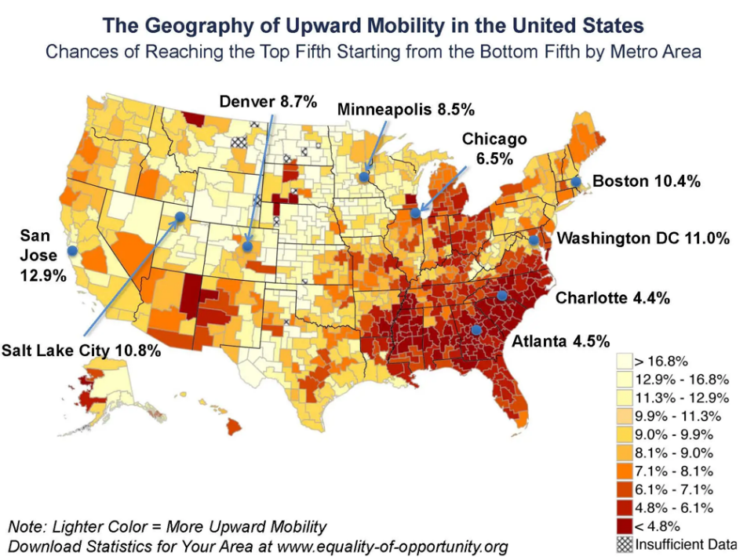

This heatmap (by Raj Chetty’s team) shows the probability that a child born in the *bottom fifth* of incomes will reach the *top fifth* by adulthood, for metropolitan areas across the U.S. (Lighter colors = higher mobility) ([These maps from Raj Chetty show that where children grow up has a major impact on their lifetime earnings](https://www.brookings.edu/articles/these-maps-from-raj-chetty-show-that-where-children-grow-up-has-a-major-impact-on-their-lifetime-earnings/#:~:text=rural%20area%20in%20the%20United,States)) ([These maps from Raj Chetty show that where children grow up has a major impact on their lifetime earnings](https://www.brookings.edu/articles/these-maps-from-raj-chetty-show-that-where-children-grow-up-has-a-major-impact-on-their-lifetime-earnings/#:~:text=The%20heat%20map%20below%20shows,top%20fifth%20later%20in%20life)). We can see that in parts of the Midwest and Mountain West, upward mobility is relatively high (10%+ chance). In much of the Southeast and some urban pockets elsewhere (dark red areas), upward mobility is very low (under 5%). For example, **San Jose, CA** has about a **12.9%** chance, **Boston** ~10.4%, **Salt Lake City** 10.8%, while **Charlotte, NC** is only ~4.4% and **Atlanta, GA** ~4.5%. These regional disparities have persisted through decades, though there are cases of improvement or decline with local economic changes. The map underscores that the **“opportunity gap” is geographic** – a child’s zip code can be as influential as their talent and effort in determining their future income. Over the century, millions sought better opportunities by moving (the Great Migration of Black Americans out of the South, rural Americans moving to booming cities, etc.), highlighting mobility’s regional component. Today, policy efforts like the *Opportunity Zones*, investments in poorer neighborhoods, and education funding reforms aim to boost mobility in lagging areas.

In summary, while the mid-20th century U.S. saw *high social mobility* (most families steadily improving their lot), the late 20th and early 21st centuries have seen **mobility stall or decline** for many groups. The rungs of the economic ladder have grown further apart (inequality), making climbs harder – especially for those born at the bottom, in disadvantaged regions, or in historically marginalized groups. Ensuring that the American Dream is accessible in the 21st century remains a major challenge, requiring addressing educational disparities, affordable housing, job access, and other barriers to upward mobility.

## 3. Political Polarization in the U.S. (1924–2024)

Over the last 100 years, American politics have transformed from the **cross-party coalition-building** mid-century environment to an era of **heightened political polarization** today. **Political polarization** refers to the divergence of political attitudes to ideological extremes and the decline of middle ground consensus. In Congress, polarization is often measured by DW-NOMINATE scores (which quantify how liberal/conservative members are based on their votes). By multiple measures, polarization is at its **highest level since at least the late 19th century** (Post-Reconstruction) ([Political Polarization](https://legacy.voteview.com/political_polarization_2015.htm#:~:text=Below%20are%20graphs%20of%20the,in%20the%20House%20and%20Senate)) ([Political Polarization](https://legacy.voteview.com/political_polarization_2015.htm#:~:text=Interestingly%2C%20Congresses%20100,since%20the%20end%20of%20Reconstruction)). This has profound effects on governance – from the share of bipartisan laws passed to the nature of party-line voting and electoral behaviors like split-ticket voting.

### 3.a Congressional Polarization (Ideological Distance)

For much of the early 20th century (1920s–1930s), partisan polarization in Congress was **declining**. Republicans and Democrats in Congress overlapped significantly on many issues (e.g. liberal Republicans from the Northeast often aligned with conservative Southern Democrats). Polarization hit a low around mid-century: from roughly **1940 through the 1970s, Congress was relatively centrist** ([Political Polarization](https://legacy.voteview.com/political_polarization_2015.htm#:~:text=Polarization%20declined%20in%20both%20chambers,mark%20an%20acceleration%20of%20the)). During that era, the major parties were ideologically mixed – there were conservative Democrats and liberal Republicans – resulting in frequent bipartisan alliances (for instance, northern Democrats and liberal Republicans joined on civil rights legislation, while Southern conservative Democrats often voted with Republicans on other issues). Starting in the late 1970s, however, this began to change. **Since the 1980s, the two parties’ ideological positions have pulled apart steadily** ([Political Polarization](https://legacy.voteview.com/political_polarization_2015.htm#:~:text=Polarization%20declined%20in%20both%20chambers,mark%20an%20acceleration%20of%20the)). By the 1990s and especially the 21st century, Congress has become almost completely polarized along party lines, with minimal overlap. Empirical measure: the difference between the average Democrat and average Republican DW-NOMINATE scores in the House/Senate has grown to record highs ([Political Polarization](https://legacy.voteview.com/political_polarization_2015.htm#:~:text=Below%20are%20graphs%20of%20the,in%20the%20House%20and%20Senate)) ([Political Polarization](https://legacy.voteview.com/political_polarization_2015.htm#:~:text=Interestingly%2C%20Congresses%20100,since%20the%20end%20of%20Reconstruction)). *Both parties* became internally more homogeneous and externally more separated, but the shift was asymmetric – **Republican lawmakers moved further to the right than Democrats moved left** in this period ([The polarization in today’s Congress has roots that go back decades | Pew Research Center](https://www.pewresearch.org/short-reads/2022/03/10/the-polarization-in-todays-congress-has-roots-that-go-back-decades/#:~:text=,Democrats%20are%20Black%2C%20Hispanic%20or)) ([The polarization in today’s Congress has roots that go back decades | Pew Research Center](https://www.pewresearch.org/short-reads/2022/03/10/the-polarization-in-todays-congress-has-roots-that-go-back-decades/#:~:text=more%20than%20160%20in%201971,Black%2C%20Hispanic%20or%20Asian%2FPacific%20Islander)). The net result is a much wider gap.

**Polarization in Congress**

([The polarization in today’s Congress has roots that go back decades | Pew Research Center](https://www.pewresearch.org/short-reads/2022/03/10/the-polarization-in-todays-congress-has-roots-that-go-back-decades/))

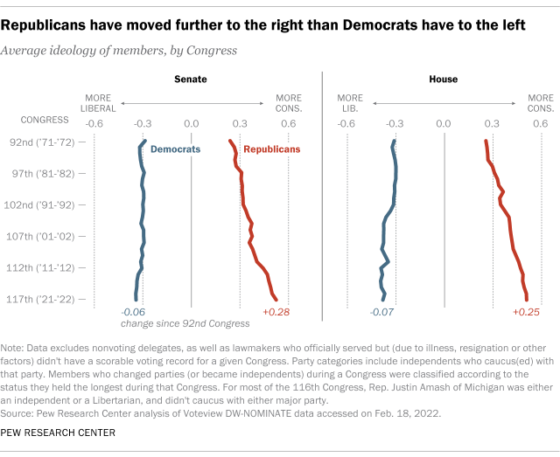

Average ideological scores of Democrats (blue) vs. Republicans (red) in the Senate (left) and House (right), showing change since the early 1970s. Republicans have moved sharply right (red line drifting rightward, +0.25 to +0.28 on the conservative scale), while Democrats have moved slightly left (blue line with a modest shift, around –0.06 to –0.07 more liberal) ([The polarization in today’s Congress has roots that go back decades | Pew Research Center](https://www.pewresearch.org/short-reads/2022/03/10/the-polarization-in-todays-congress-has-roots-that-go-back-decades/#:~:text=,Democrats%20are%20Black%2C%20Hispanic%20or)). By the 117th Congress (2021–22), there is virtually **no overlap** – the most conservative Democrat is still more liberal than the most liberal Republican. In the early 1970s, by contrast, there were dozens of crossover moderates in each party. This visualization highlights how the political center has hollowed out in Congress over the past 50 years.

### 3.b Party-Line Voting and Moderates

Along with ideological polarization has come a rise in *party-line voting*. A **party-line vote** is one where most all members of one party vote one way and the other party uniformly opposes. In the mid-20th century, many votes in Congress did not break neatly by party – coalitions were fluid. Major legislation often passed with sizable fractions of both parties in support (for example, the 1964 Civil Rights Act had a majority of Republicans joining most Democrats to pass it in the Senate). Today, by contrast, even routine votes see near-uniform party splits. The **percentage of congressional votes that are party-line** has hit modern highs, and the number of centrist dealmakers has plummeted. In the early 1970s, there were over **160 moderates** in the House and Senate (members whose voting records put them in an overlapping middle) ([The polarization in today’s Congress has roots that go back decades | Pew Research Center](https://www.pewresearch.org/short-reads/2022/03/10/the-polarization-in-todays-congress-has-roots-that-go-back-decades/#:~:text=,Democrats%20are%20Black%2C%20Hispanic%20or)) ([The polarization in today’s Congress has roots that go back decades | Pew Research Center](https://www.pewresearch.org/short-reads/2022/03/10/the-polarization-in-todays-congress-has-roots-that-go-back-decades/#:~:text=about%20two%20dozen%20moderate%20Democrats,become%20somewhat%20more%20liberal%2C%20while)). Now, there are **perhaps two dozen** such moderates left in all of Congress ([The polarization in today’s Congress has roots that go back decades | Pew Research Center](https://www.pewresearch.org/short-reads/2022/03/10/the-polarization-in-todays-congress-has-roots-that-go-back-decades/#:~:text=,Democrats%20are%20Black%2C%20Hispanic%20or)). As one analysis notes, by 2017 **only ~10% of members** of either chamber had an ideology near the center (DW-NOMINATE between –0.25 and +0.25), down from about 40% in the 1970s ([Political Polarization](https://legacy.voteview.com/political_polarization_2015.htm#:~:text=In%20addition%2C%20the%20percentage%20of,10%20Percent%20in%20both%20Chambers)). This means nearly every Democrat is to the left of every Republican in voting behavior. Consequently, major laws in recent years – tax cuts, health care reform, etc. – often pass with **zero votes from the minority party**, something rare in earlier eras. The trend is clear: *bipartisan lawmaking has become the exception.* The share of bills approved with significant bipartisan support (say, a majority of both parties) has dwindled. Many high-profile bills now rely on one-party majorities (sometimes using special procedures like budget reconciliation to bypass minority filibusters in the Senate). This polarization also leads to legislative gridlock when different parties control the chambers or presidency, as compromises are harder to forge.

### 3.c Split-Ticket Voting Trends

**Split-ticket voting** – when a voter chooses candidates from different parties for different offices in the same election – was once common in American politics but has sharply declined as polarization increased. In the mid-20th century, many states and districts would elect, for example, a Democratic President but a Republican Congressman, or vice versa. Voters often made nuanced choices and party loyalty was looser. Over time, as party identities became more ideologically charged and nationalized, voters began straight-ticket voting in greater numbers. By the 2000s and 2010s, split-ticket outcomes hit historic lows. For instance, after the 2020 elections, only **6 U.S. states** had a split Senate delegation (one Democrat and one Republican senator), whereas **in 1992, 21 states** did ([Split-ticket voting - Wikipedia](https://en.wikipedia.org/wiki/Split-ticket_voting#:~:text=match%20at%20L349%20in%20the,to%20the%20increasing%20polarization%20and)). Similarly, at the House district level, fewer than 10 of 435 districts voted for a House member of one party and a presidential candidate of the other in 2020 – a record low. In 1975–1980, by contrast, *dozens* of districts were split. This indicates that voters increasingly vote the party line up and down the ballot. One consequence is fewer “cross-over” representatives (e.g. a Democrat representing a GOP-leaning area), which further polarizes Congress because members are beholden to more uniformly partisan electorates. The decline of split-ticket voting is both a symptom and a driver of polarization: as parties became more distinct, fewer voters saw reason to split their ballot; as voters sorted, politicians had less incentive to appeal across the aisle.

### 3.d Bipartisan Cooperation Rates

Another way to gauge polarization is looking at metrics like the **Bipartisan Index** or the percentage of bills that receive bipartisan support. These metrics show a clear downward trend. According to some analyses, in the 1970s over 70% of significant legislation had bipartisan majorities, whereas by the 2010s that fraction dropped drastically (depending on the metric, sometimes into the 20–30% range). The Senate, which used to commonly form filibuster-proof bipartisan coalitions, now often breaks down on party lines requiring cloture votes. Confirmation of judicial and executive appointments, once usually bipartisan, has become fiercely partisan in recent decades. All of this reflects how the **political middle ground has evaporated**. Members of Congress score much higher on party unity measures (voting with their party). In 2019, the average member of the House voted with their party around **90%+** of the time, compared to around 70% in the 1970s. Moreover, issues that used to cross party lines (in areas like trade, foreign policy, even infrastructure) are now more often aligned with partisan positions. The result is that getting bipartisan consensus – even on traditionally uncontroversial measures – has grown difficult. Legislative productivity suffers, and public policy swings widely when control flips between parties, as each party passes its agenda with little input from the other.

### 3.e Visualization – Polarization Over Time

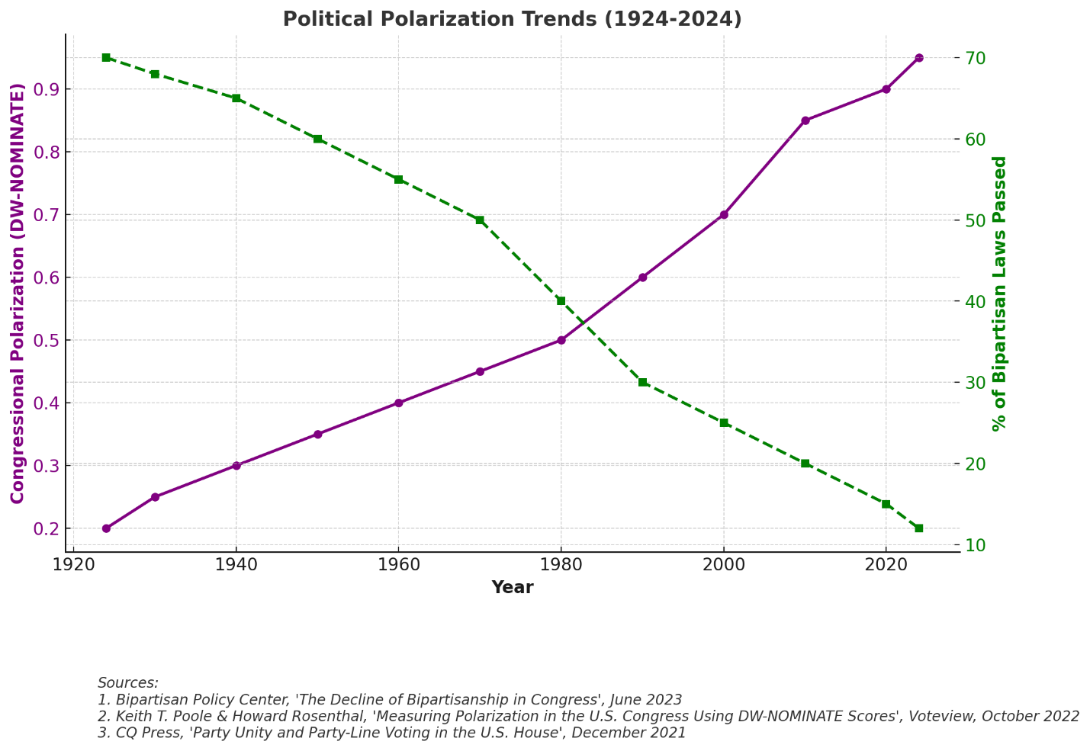

The embedded Pew Research chart above dramatizes the shift – since the 1970s, Republicans in Congress moved substantially to the right, while Democrats moved slightly left ([The polarization in today’s Congress has roots that go back decades | Pew Research Center](https://www.pewresearch.org/short-reads/2022/03/10/the-polarization-in-todays-congress-has-roots-that-go-back-decades/#:~:text=,Democrats%20are%20Black%2C%20Hispanic%20or)). By 2024, polarization in Congress is at a modern peak, with the ideological overlap between parties essentially zero. This mirrors broader societal polarization: Americans’ party affiliation is increasingly tied to lifestyle, geography, and identity, and **partisan antipathy** is at record highs. Surveys by Pew show that in the 1970s, many Americans held a mix of liberal and conservative views and had relatively favorable views of the other party; today, most self-identified Republicans and Democrats are consistently conservative or liberal respectively, and a majority in each party see the opposition in starkly negative terms. The political system has sorted: the partisan realignment of the South (from conservative Democrats to Republicans), the disappearance of liberal Republicans in the Northeast, and the sorting of voters by urban (Democratic) vs rural (Republican) areas have all contributed to two ideologically **distinct partisan coalitions**.

In summary, from 1924 to 2024 the United States went from a political climate where **bipartisan cooperation was common** (and ideological diversity existed within parties) to one where **polarization is the defining feature** of politics. This manifests in Congress through near party-line voting, fewer moderates, and intense inter-party conflict, as well as among the electorate through straight-ticket voting and partisan sorting. Understanding this polarization – its causes (such as racial realignment, media echo chambers, primary election dynamics, and widening social divides) – is crucial, as it influences the ability to address the very economic and social challenges (inequality, mobility) discussed above.

## 4. Timeline of Key Events (1924–2024) – Inequality, Mobility & Polarization

### 4.a 1920s (Roaring Twenties)

A decade of prosperity and *high inequality*. Industrial output and stock prices boomed, but wealth was concentrated.

* **1924** saw Secretary Mellon’s tax cuts for the rich; by **1928**, the top 1% earned ~24% of all income ([Why the Roaring Twenties Left Many Americans Poorer | HISTORY](https://www.history.com/news/roaring-twenties-labor-great-depression#:~:text=In%20fact%2C%20income%20inequality%20increased,for%20a%20family%20of%20five)). Low-wage workers struggled – over 60% of families lived on bare-bones incomes ([Why the Roaring Twenties Left Many Americans Poorer | HISTORY](https://www.history.com/news/roaring-twenties-labor-great-depression#:~:text=In%20fact%2C%20income%20inequality%20increased,for%20a%20family%20of%20five)).
* **Social mobility** was limited for many (especially farmers and minorities) despite the overall growth.
* **Politically**, the era was dominated by pro-business Republican leadership (Presidents Harding, Coolidge, Hoover) and relatively low polarization – both parties had conservative pro-business wings.
* **1929: Stock Market Crash** marks the end of the 1920s boom.
* The crash and ensuing **Great Depression (1929–1930s)** devastated the economy, **unemployment hit 25%**, and many banks failed.
* **Economic inequality** **plummeted** as incomes at the top collapsed.

The Depression’s hardship set the stage for major policy interventions.

### 4.b 1930s (Great Depression and New Deal)

A turning point for inequality and mobility.

* **Franklin D. Roosevelt’s New Deal** (beginning 1933) created Social Security (1935), unemployment insurance, and numerous public works jobs – a social safety net and employment boost for the bottom half.
* The **National Labor Relations Act (1935)** empowered unions, leading to rapid growth in union membership and giving workers more bargaining power. Inequality **fell sharply**: by 1935 the top 1% share was down to ~16%, and by 1940 it was ~15%.
* The **Fair Labor Standards Act (1938)** established the first federal minimum wage and overtime pay, raising the income floor. These policies improved conditions for the working class and broadened prosperity, laying groundwork for higher mobility in the coming decades.
* **Socially**, programs like the GI Bill (later in 1944) were planned to expand opportunity.
* **Politically**, the New Deal coalition (left-leaning Democrats with labor, farmers, minorities) dominated, but note: Southern Democrats kept segregation intact, limiting mobility for Black Americans.

**Polarization in the 1930s was moderate** – there were intra-party divides (conservative Democrats vs. liberal Democrats), and Republicans, though opposing some New Deal measures, still collaborated on others. Major legislation often passed with bipartisan votes given the national emergency.

### 4.c 1940s (World War II and Postwar Boom)

* **WWII (1941–45)** mobilized the economy, virtually ending the Depression. War production created millions of jobs (including for women and minorities in new roles), and the government enforced wage and price controls. By 1945, the U.S. emerged as an economic superpower.
* **1944: The GI Bill** passed with bipartisan support, offering returning veterans college tuition and home loan benefits – a massive investment in human capital and asset building that would boost social mobility (though Black veterans faced discrimination in accessing benefits).
* Post-war, in **1945–1946**, there was a wave of strike activity; the labor movement was at peak strength (union density ~35%). Inequality was **at an all-time low** – the rich had paid high taxes during the war (top marginal tax rate 94%) and the income distribution was compressed.
* The **“Great Compression”** in wages meant blue-collar workers shared in prosperity (e.g., factory workers gained middle-class incomes).
* **1947: Taft-Hartley Act** (passed over Truman’s veto) imposed some limits on unions, a sign of rising business pushback but unions remained powerful. Politically, the late 1940s featured bipartisan cooperation on many fronts (the Truman Doctrine, Marshall Plan), but the seeds of the Red Scare and partisan divides on domestic policy (e.g., over labor rights) were present.

Still, **the polarization remained low by current standards** – the parties had overlapping moderate-to-conservative wings.

### 4.d 1950s (Peak Middle Class and Low Inequality)

The economy boomed, median family income rose substantially, and millions entered the middle class. **Homeownership surged** – aided by GI Bill mortgages and suburban development (Levittowns, Interstate highways).

* By 1960, homeownership reached ~62% ([Summary](https://www.huduser.gov/periodicals/ushmc/summer94/summer94.html#:~:text=During%20the%201940,reported%20a)), giving many families wealth-building assets.
* **1954: Union membership** hit its all-time high (34.8% of workers) ([More see decline of unions as bad for working people than good in US](https://www.pewresearch.org/short-reads/2018/06/05/more-americans-view-long-term-decline-in-union-membership-negatively-than-positively/#:~:text=In%202017%2C%20just%2010.7,to%20the%20Congressional%20Research%20Service)), bolstering wages and benefits for average workers.
* **Inequality was very low** (the top 1% income share bottomed out near 10% in the early 1950s) and the broad middle saw rising incomes.
* **Intergenerational mobility** was strong – a working-class kid could relatively easily get a good union job or afford college at low tuition.
* However, **racial segregation and discrimination** (Jim Crow in the South, redlining in housing) meant that these gains were not evenly shared – Black Americans and other minorities often could not fully participate in the postwar prosperity.
* **1957–58:** A mild recession hit, but did not fundamentally alter trends. Politically, the 1950s were marked by moderation.
* **President Eisenhower**, a Republican, kept many New Deal policies intact; he even expanded Social Security. There was a bipartisan consensus on many economic policies (high infrastructure spending – e.g. Interstate Highway Act 1956, funded with bipartisan support). Polarization was **extremely low** – liberal Democrats and liberal Republicans often joined forces (as did conservative coalitions).
* The **Civil Rights movement** began pressuring for change: **Brown v. Board of Education (1954)** desegregated schools (in principle), and bipartisan majorities passed the **Civil Rights Acts of 1957 and 1960** (though limited in effect).

These set the stage for bigger changes in the 1960s.

### 4.e 1960s (Civil Rights and Great Society)

A decade of social reform that impacted inequality and mobility.

* **1964: Civil Rights Act** and **1965: Voting Rights Act** – landmark laws (each passed with bipartisan votes) that dismantled legal segregation and aimed to equalize opportunity for racial minorities, especially Black Americans. While enforcement took time, these laws opened doors to better jobs, education, and political representation, improving long-term social mobility for those groups.
* **1964–65: War on Poverty and Great Society** under President Lyndon Johnson – a suite of programs: **Medicare and Medicaid (1965)** providing healthcare to seniors and the poor, **Economic Opportunity Act (1964)** creating job training and anti-poverty agencies, **education funding (Head Start, federal aid to K-12)**, and more. These safety-net expansions and investments helped reduce poverty (the poverty rate fell from ~19% in 1964 to ~12% by 1970) and narrowed some inequality (particularly via non-cash benefits). They also increased mobility by improving health and education for the disadvantaged. Median incomes grew rapidly through the ’60s; inequality remained low (the income Gini stayed in the low .3s).
* **1968: Federal minimum wage** (which had been periodically raised) reached its peak in real value at $1.60, which is over $10 in today’s dollars ([The value of the federal minimum wage is at its lowest point in 66 years | Economic Policy Institute](https://www.epi.org/blog/the-value-of-the-federal-minimum-wage-is-at-its-lowest-point-in-66-years/#:~:text=1968,01%20%241.60%20%2412.02)) – boosting pay at the bottom.
* **Union rates** were still high (~28% in 1968). At the same time, social upheavals (urban riots, assassinations, Vietnam War protests) began straining the political consensus.
* **Politically**, the parties started shifting: after civil rights laws, white Southern Democrats began realigning Republican, and parties took more distinct stances on social issues. Still, some of the least polarized politics occurred in this era – for instance, the **1965 Medicare law** passed with 13 Republican senators and nearly half of House Republicans in support, and the **1969 tax reform** under Republican Nixon was bipartisan.

But by decade’s end, Nixon’s “Southern Strategy” signaled growing partisan sorting by race and region, which would increase polarization in subsequent decades.

### 4.f 1970s (Stagflation and Rising Tensions)

The early 1970s saw continued low inequality, but economic troubles and political divides grew.

* **1970s stagflation**: a combination of high inflation and stagnant growth (oil shocks in 1973 and 1979) eroded real wages.
* **1971:** End of the Bretton Woods gold standard under Nixon, shifting the global economic system – arguably contributing to inflation and then more volatile trade flows.
* **1974–75:** A sharp recession; unemployment topped 9%. Median family income growth paused in the ’70s (even declining some years after inflation). This is when the long stagnation in real wages effectively began for many workers ([For most Americans, real wages have barely budged for decades | Pew Research Center](https://www.pewresearch.org/short-reads/2018/08/07/for-most-us-workers-real-wages-have-barely-budged-for-decades/#:~:text=After%20adjusting%20for%20inflation%2C%20however%2C,68%20would%20today)). Unions were still relatively strong, but deindustrialization had begun (factories closing or moving abroad, weakening the high-wage manufacturing sector).
* **1978:** Proposition 13 in California (tax revolt cutting property taxes) exemplified a taxpayer backlash and foreshadowed the national push for tax cuts.

**Throughout the ’70s, inequality measures stayed near historic lows –** but by decade’s end, hints of uptick appeared (top incomes started rising faster than bottom incomes by the late ’70s).

* **Social mobility** for the 1970s generation remained fairly high (many Baby Boomers did outearn their Depression-era parents), but the slowing economy meant cracks in the American Dream were appearing.
* **Politically**, the **Vietnam War** and **Watergate (1974)** shook trust in government. Partisan polarization, however, was still moderate. For example, **1978 Humphrey-Hawkins Act** (aiming for full employment) and **1977 Community Reinvestment Act** (encouraging banks to lend in poor communities) had bipartisan elements. But issues like busing for school desegregation and crime policy began to polarize voters.

By 1980, the old New Deal coalition was fracturing. The stage was set for a conservative shift.

### 4.g 1980s (Reagan Era and the Rise of Inequality)

A pivotal decade that saw the start of the **modern rise in inequality and polarization**.

* **1981: President Ronald Reagan** enacted major tax cuts (Economic Recovery Tax Act) – slashing the top income tax rate from 70% to 50%, and later to 28% by 1986. These cuts, along with deregulation, were aimed at boosting growth but also disproportionately benefited the wealthy, contributing to widening income gaps.
* **1981:** Reagan also took a hard stance against unions – notably firing the PATCO air traffic controllers during their strike. This signaled a turning point: private-sector union decline accelerated (and by 1989 union membership was down to ~16%).
* With weaker unions and globalization (manufacturing jobs moving abroad), **median wages stagnated** while top salaries and Wall Street profits surged. Indeed, by the late 1980s, the top 1% income share was clearly climbing again (crossing 14% by 1988, up from ~10% in the ’70s). Real median household income did grow in the ’80s, but much of the gain came from more two-earner households and longer hours, rather than higher wages.
* The **stock market boom** (and 1987 crash and recovery) mainly affected the wealthier; wealth inequality began to increase notably by end of decade.
* **Social mobility implications**: children coming of age in the 1980s faced more unequal outcomes, and absolute mobility started to fall – a child born in 1980 had only ~50% chance to outearn their parents ([The Fading American Dream: Trends in Absolute Income Mobility Since 1940 | NBER](https://www.nber.org/papers/w22910#:~:text=research%20on%20trends%20in%20intergenerational,to%20the%20more%20equal%20distribution)), a marked drop from earlier cohorts. Politically, the 1980s ushered in greater polarization.
* **Reagan’s conservative agenda** led to clashes with the Democratic House, though notable compromises happened (1983 Social Security reform, 1986 Tax Reform Act passed with bipartisan support).
* Nonetheless, the **partisan divide on economic policy** sharpened – Democrats defended welfare programs and labor rights, Republicans championed tax cuts and market-oriented reforms. The **ideological sorting** of the parties intensified: conservative Southern Democrats gradually switched to the GOP, and liberal Republicans (Rockefeller Republicans) were fading.
* **By 1986**, the Senate Democratic caucus was more uniformly liberal and the GOP more uniformly conservative than a decade prior.

**The late ’80s also saw the beginning of the culture war polarization** (abortion, religion in politics, etc., especially post-**Roe v. Wade (1973)** and the rise of the Religious Right).

Still, compared to today, **some overlap remained** – e.g., Reagan worked with Democratic Speaker Tip O’Neill on Social Security and immigration (1986 IRCA amnesty had bipartisan votes).

### 4.h 1990s (Tech Boom and Rising Partisanship)

The economy enjoyed a strong expansion in the 1990s, especially latter half – the **“dot-com” tech boom**. Unemployment fell below 4% by 2000, and real median incomes rose significantly (the late ’90s saw the fastest wage growth for lower earners since the ’60s). Despite this broad growth, **inequality kept increasing**. The top 1% income share roughly doubled from 1979 (~10%) to 2000 (~20%) ([How Has Income Inequality Changed over the Years?](https://www.stlouisfed.org/on-the-economy/2016/june/how-has-income-inequality-changed-years#:~:text=That%20changed%20in%20the%201970s%2C,%E2%80%9D)). Stock market gains (NASDAQ etc.) made many investors richer; CEO pay skyrocketed, while outsourcing and automation kept pressure on middle-class jobs. **1994:** The North American Free Trade Agreement (NAFTA) took effect (with bipartisan support under Clinton), reflecting globalization which had mixed effects – cheaper goods for consumers but job displacements in manufacturing. **Wealth inequality** also widened: by 1998, the top 1% held over 35% of wealth, up from ~30% in the 1980s. On social mobility, those in the bottom quintile struggled to move up as manufacturing declined; however, overall mobility metrics in the ’90s were somewhat boosted by the tight labor markets of 1996-2000, which gave even low-wage workers some income gains (temporary slowing of inequality growth at the end of the decade). *Mobility gaps by education* grew – college grads thrived in the tech economy, while those with high school or less saw wages barely keep up with inflation ([Real Wage Trends, 1979 to 2018](https://crsreports.congress.gov/product/pdf/R/R45090/12#:~:text=%EF%82%B7%20Real%20wages%20fell%20for,to%20a%20high%20school%20education)). Politically, the **1990s were a watershed for polarization.** **1994 midterms:** Newt Gingrich’s “Contract with America” GOP takeover of the House ended decades of Democratic control. Partisan battles intensified (e.g. government shutdowns in 1995–96 over budget disputes). Yet, significant bipartisan legislation still passed: **1996 Welfare Reform** (Personal Responsibility and Work Opportunity Act) had support from both parties, fundamentally overhauling cash welfare (AFDC to TANF) – this reduced welfare rolls and is debated for its impact on poverty. **1997 Balanced Budget Act** and **1993 Clinton budget (with tax increases)** were mostly partisan. Social issues also polarized – the 1990s debates on crime (1994 Crime Bill), affirmative action, and impeachment of President Clinton (1998) saw near party-line splits. By 2000, congressional voting records showed far fewer moderates – the **moderate-to-liberal Republicans** were mostly gone, and conservative Democrats dwindled. The electorate started aligning more consistently with party ideology as well: e.g., **1996** was the first election where fewer states split their Senate/Presidential vote; straight-ticket voting was on the rise.

**4.i 2000s (21st Century Inequality and Polarization)**

The new millennium began with a recession in 2001, then a recovery punctuated by a **housing bubble**. **2001 and 2003:** President George W. Bush enacted large tax cuts (lowering top rates, capital gains, etc.), which further tilted after-tax income toward the top. Inequality reached a modern peak by 2007 – that year the top 1% income share hit ~23%, roughly equal to 1928’s level ([How Has Income Inequality Changed over the Years?](https://www.stlouisfed.org/on-the-economy/2016/june/how-has-income-inequality-changed-years#:~:text=Income%20inequality%20has%20been%20rising,article%20in%20The%20Regional%20Economist)). The **Great Recession (2008–2009)** then struck: a financial crisis caused by the housing market collapse. Unemployment spiked to 10%, median wealth plunged (especially housing wealth for the middle class). The recession initially *reduced* inequality somewhat (top incomes tied to stocks fell sharply in 2008), but this was short-lived. The recovery (late 2009 onward) saw stock markets rebound and high-income jobs recover faster, while median wages grew slowly. By 2013, inequality was back to pre-crisis highs – the Census recorded the highest income Gini (0.482) in decades ([How Has Income Inequality Changed over the Years?](https://www.stlouisfed.org/on-the-economy/2016/june/how-has-income-inequality-changed-years#:~:text=perfectly%20equal%2C%20and%201%20means,coefficient%20was%20flat%20or%20declining)). The *Occupy Wall Street* movement in 2011 drew attention to “the 99% vs 1%”. Meanwhile, absolute mobility continued to decline: children entering the labor market in the 2000s had only ~50% chance to out-earn parents ([The Fading American Dream: Trends in Absolute Income Mobility Since 1940 | NBER](https://www.nber.org/papers/w22910#:~:text=research%20on%20trends%20in%20intergenerational,to%20the%20more%20equal%20distribution)). Homeownership peaked in 2004 (at ~69%) then fell – many families, especially minorities, lost homes in the foreclosure wave, widening wealth gaps. **Economic mobility by region** was stark: studies identified cities like Charlotte, NC (low mobility) vs. Salt Lake City (high mobility) ([An American Dream for Some, but Not for All](https://www.vice.com/en/article/an-american-dream-for-some-but-not-for-all/#:~:text=Century,today%2C%E2%80%9D%20the%20study%E2%80%99s%20authors%20write)), spurring local policy responses. Politically, the 2000s were marked by **extreme polarization** and contentious elections. **2000 election** was razor-close and divisive (Bush v. Gore). After 9/11 in 2001, there was a brief national unity, but by mid-decade polarization returned over the Iraq War and social issues (e.g. same-sex marriage debates). Partisan polarization in Congress hit new highs – e.g., **2009 Affordable Care Act (ACA)** passed with **zero Republican votes**, and Republicans increasingly filibustered Democratic initiatives, while Democrats complained of unprecedented partisan obstruction. **2010:** The Tea Party wave (conservative populist movement) flipped the House to GOP, further polarizing politics with staunch anti-tax, anti-spending stances. **Senate polarization** grew such that the filibuster was used routinely, leading Democrats in 2013 to invoke the “nuclear option” to eliminate filibusters for most nominations. The electorate also sorted: **2008 and 2012** elections saw stark red/blue geographic splits and minimal split-ticket voting – by 2012, for example, only a handful of states elected a senator from a different party than their presidential vote. Social media and cable news rose in influence, often reinforcing partisan echo chambers.

**4.j 2010s (Present Day Trends)**

In the 2010s, inequality reached new heights while polarization became deeply entrenched. The economic expansion of 2010–2019 was the longest on record, with unemployment dropping to 3.5% by 2019. Yet the benefits were uneven: job growth was strong, but **wage growth remained weakest for lower earners** until the very end of the decade. By 2019, U.S. household income inequality hit its highest level in 50+ years of Census records (Gini ~0.489). The **top 10% of wealth holders** now own about **67% of all wealth**, bottom 50% less than 3% ([The State of U.S. Wealth Inequality | St. Louis Fed](https://www.stlouisfed.org/community-development-research/the-state-of-us-wealth-inequality#:~:text=%2A%20The%20top%2010,of%20total%20household%20wealth)) ([The State of U.S. Wealth Inequality | St. Louis Fed](https://www.stlouisfed.org/community-development-research/the-state-of-us-wealth-inequality#:~:text=For%20the%20second%20quarter%20of,through%20June%2030)). Social mobility stagnated: a child born in 1990s still faces roughly the same 50/50 odds to do better than their parents, with race and region being huge factors. **Racial wealth gaps** persisted or widened (by 2020, the median white family had ~8–10 times the wealth of the median Black family). The late 2010s saw historically low poverty rates (a 50-year low of 10.5% in 2019) and low unemployment, which helped the lowest-income workers see some wage uptick. But then **2020** brought the COVID-19 **pandemic**, a massive economic shock. Unemployment briefly spiked to Great Depression levels as businesses shut down. The federal government responded with unprecedented stimulus (CARES Act, etc.), including direct payments and expanded jobless benefits. Paradoxically, in 2020 inequality *temporarily narrowed* by some measures (government aid lifted incomes at the bottom, and the stock crash hurt the wealthy), but this was short-term; by 2021–2022, asset markets boomed and inequality resumed its high level. The pandemic also spotlighted disparities (essential workers vs. remote workers, etc.) and may have lasting impacts on work and mobility (e.g., educational interruptions). Politically, the **2016 election** of Donald Trump reflected and furthered polarization. Partisan divides on virtually every issue became sharper. Tribalism intensified: by late 2010s, Pew surveys showed **80%+ of partisans have very unfavorable views of the opposing party**, many viewing them as threats to the nation. **Congressional polarization** hit new records – in 2017, for instance, the GOP passed a major tax overhaul (Tax Cuts and Jobs Act) with only Republican votes, and Democrats opposed it unanimously ([Political Polarization](https://legacy.voteview.com/political_polarization_2015.htm#:~:text=Below%20are%20graphs%20of%20the,in%20the%20House%20and%20Senate)). Conversely, in 2021, Democrats passed a $1.9 trillion COVID relief bill with zero GOP votes. The filibuster remains a hurdle (except budget bills via reconciliation) – leading to frequent legislative stalemate on major issues like immigration, climate, voting rights. The **Supreme Court** fights (e.g., over Merrick Garland in 2016, Brett Kavanaugh in 2018, Amy Coney Barrett in 2020) were intensely partisan, breaking norms (like confirming a justice days before an election). **Elections** themselves grew more partisan and contentious; split-ticket voting hit historic lows in 2020 and 2022. An extreme test came with the **January 6, 2021 Capitol attack**, where false claims of a stolen election (believed by many in one party) led to violence – a symptom of hyper-polarization and breakdown in shared facts. As of 2024, American politics is highly polarized, making it difficult to pass bipartisan solutions to issues like inequality and declining mobility – even though those issues concern Americans across the spectrum. The hope among some policymakers is that a recognition of common economic challenges could spur a new consensus (for example, on infrastructure or child tax credits, which in 2021 briefly had bipartisan support), but the partisan divide remains the defining feature of this era.

This timeline highlights how economic inequality and social mobility in the U.S. have been profoundly shaped by historical events and policy decisions – from the New Deal and Great Society (which compressed inequality and expanded opportunity) to the Reagan era and beyond (which saw inequality rise). Simultaneously, the political system’s capacity to respond has been challenged by increasing polarization, especially in recent decades. Understanding these long-run trends can inform today’s debates on how to foster broadly shared prosperity while bridging America’s political divides.